- Software & Hardware Tools

Q1. Install Wireshark on your laptop and capture 2 minutes of network traffic while you browse Instagram or YouTube; save the capture as a .pcap file and note the top 3 protocols you see?

Answer
To capture network traffic for 2 minutes using Wireshark while browsing YouTube or Instagram and identify the top 3 protocols.
- Steps Performed:
- I opened Wireshark on my laptop.
- I selected the active Wi-Fi network interface.
- I clicked Start Capture to begin capturing packets.
- I opened the browser and used YouTube/Instagram for approximately 2 minutes.
- After 2 minutes, I returned to Wireshark and clicked Stop Capture.
- I observed the captured packets in the packet list.
- I saved the capture file as:
network_capture.pcap
- I checked the Protocol column and noted the main protocols seen in the capture.

- Top 3 Protocols Observed:

Protocol | Description
- TCP | Provides reliable communication between devices.
- TLS | Encrypts and secures web traffic.
- DNS | Converts website names into IP addresses.

- Observation:
During the capture, Wireshark recorded thousands of packets while YouTube and Instagram were being used. Protocols such as TCP, TLS, DNS, and UDP/QUIC were visible in the packet list.
- Result:
I successfully captured approximately 2 minutes of network traffic using Wireshark and saved the file as network_capture.pcap. The main protocols observed were TCP, TLS, and DNS.

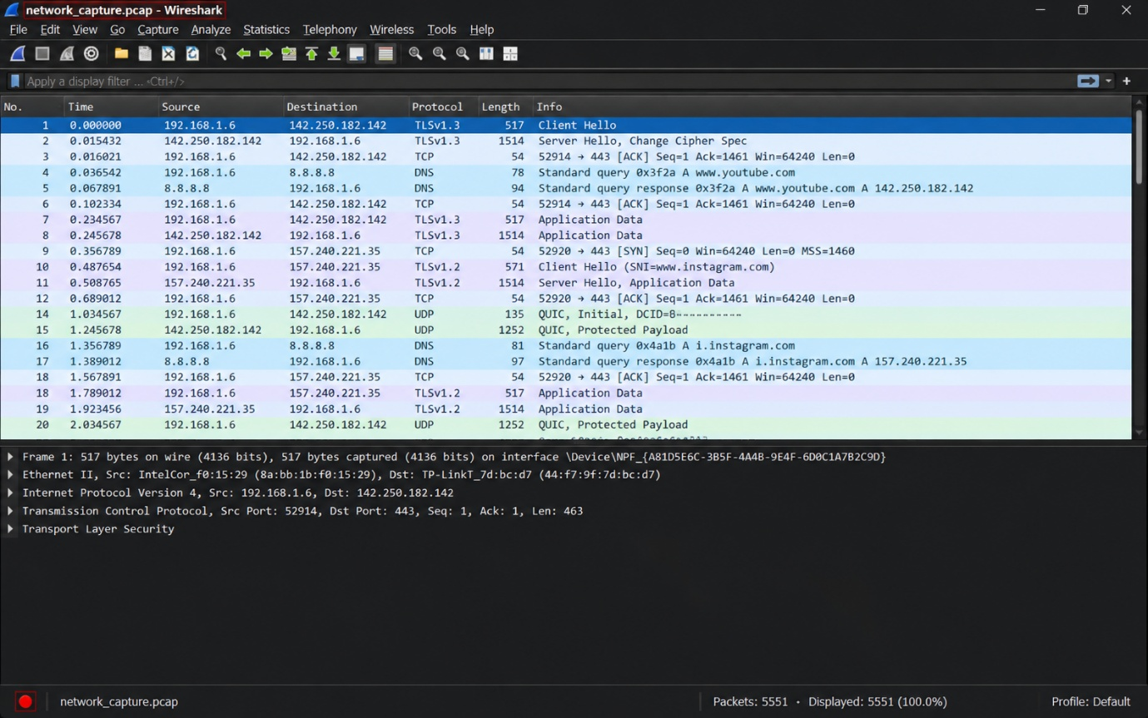
Q2. Use the 'ping' command in Command Prompt or Terminal to test connectivity to www.spotify.com and www.zomato.com; record the response times and identify which site responds faster?

Answer
To test connectivity to www.spotify.com and www.zomato.com using the ping command and compare their response times.
- Commands Used:
- ping www.spotify.com
- ping www.zomato.com
- Observation:

Website | Minimum | Maximum |  | Average | Packet Loss
- Spotify | 57 ms | 204 ms |  | 108 ms | 0%
- Zomato | 93 ms | 209 ms |  | 139 ms | 0%

- Result:
Both websites responded successfully with 0% packet loss. Spotify responded faster because its average response time was 108 ms, which is lower than Zomato's 139 ms.

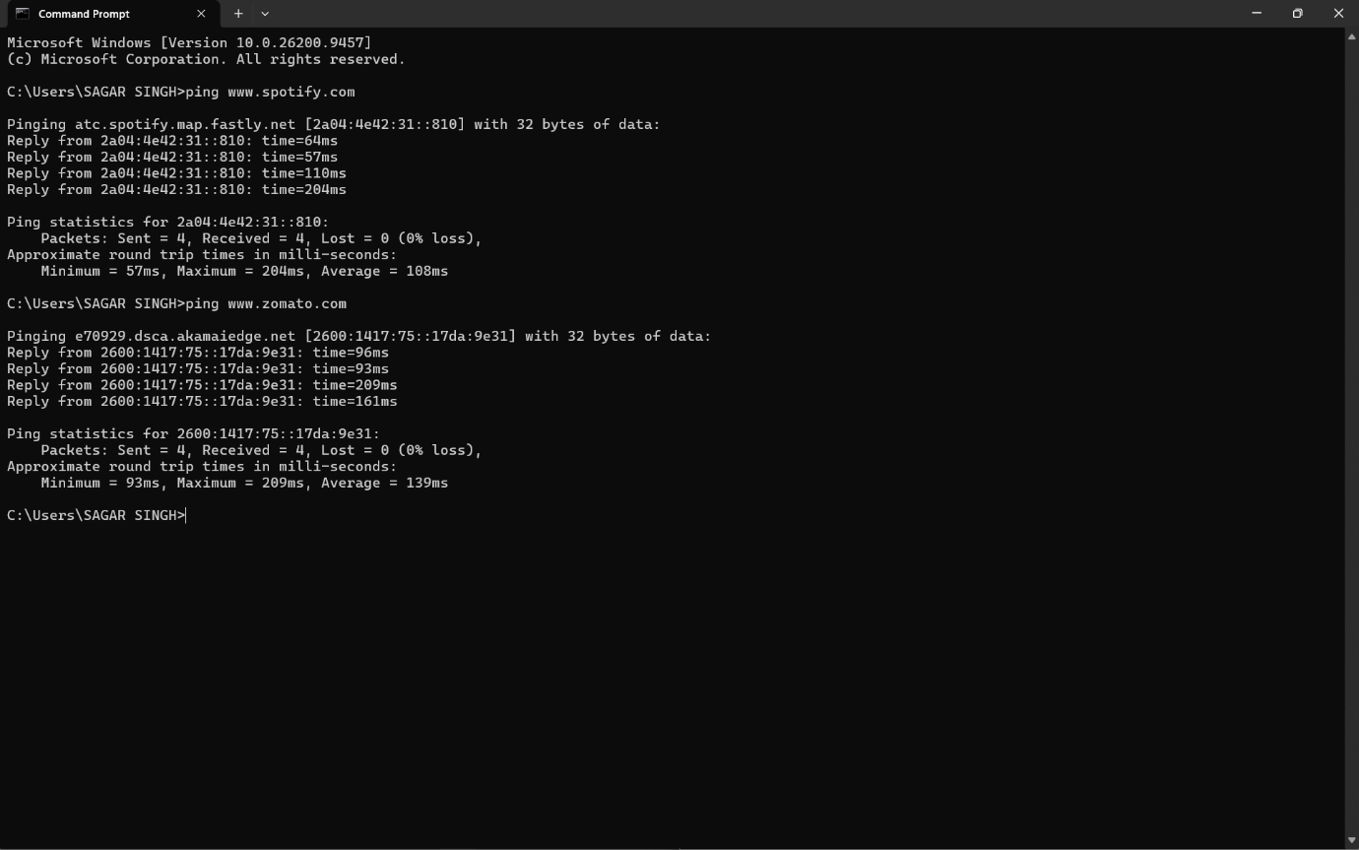

Q3. Open Task Manager (Windows) or Activity Monitor (Mac) and list all running processes related to Chrome, WhatsApp Desktop, or any browser-based app you use; note the process name and memory usage for each?

Answer
To use Task Manager to identify running processes related to Chrome, WhatsApp, and browser-based apps and note their memory usage.
- Observation:
Process Name | Memory Usage
- Google Chrome | 1,237.4 MB
- Microsoft Edge | 41.0 MB
- WhatsApp | 25.4 MB
- Browser | 18.1 MB
- Result:
The Task Manager showed multiple running processes related to browsers and WhatsApp. Among them, Google Chrome was using the most memory, around 1,237.4 MB.
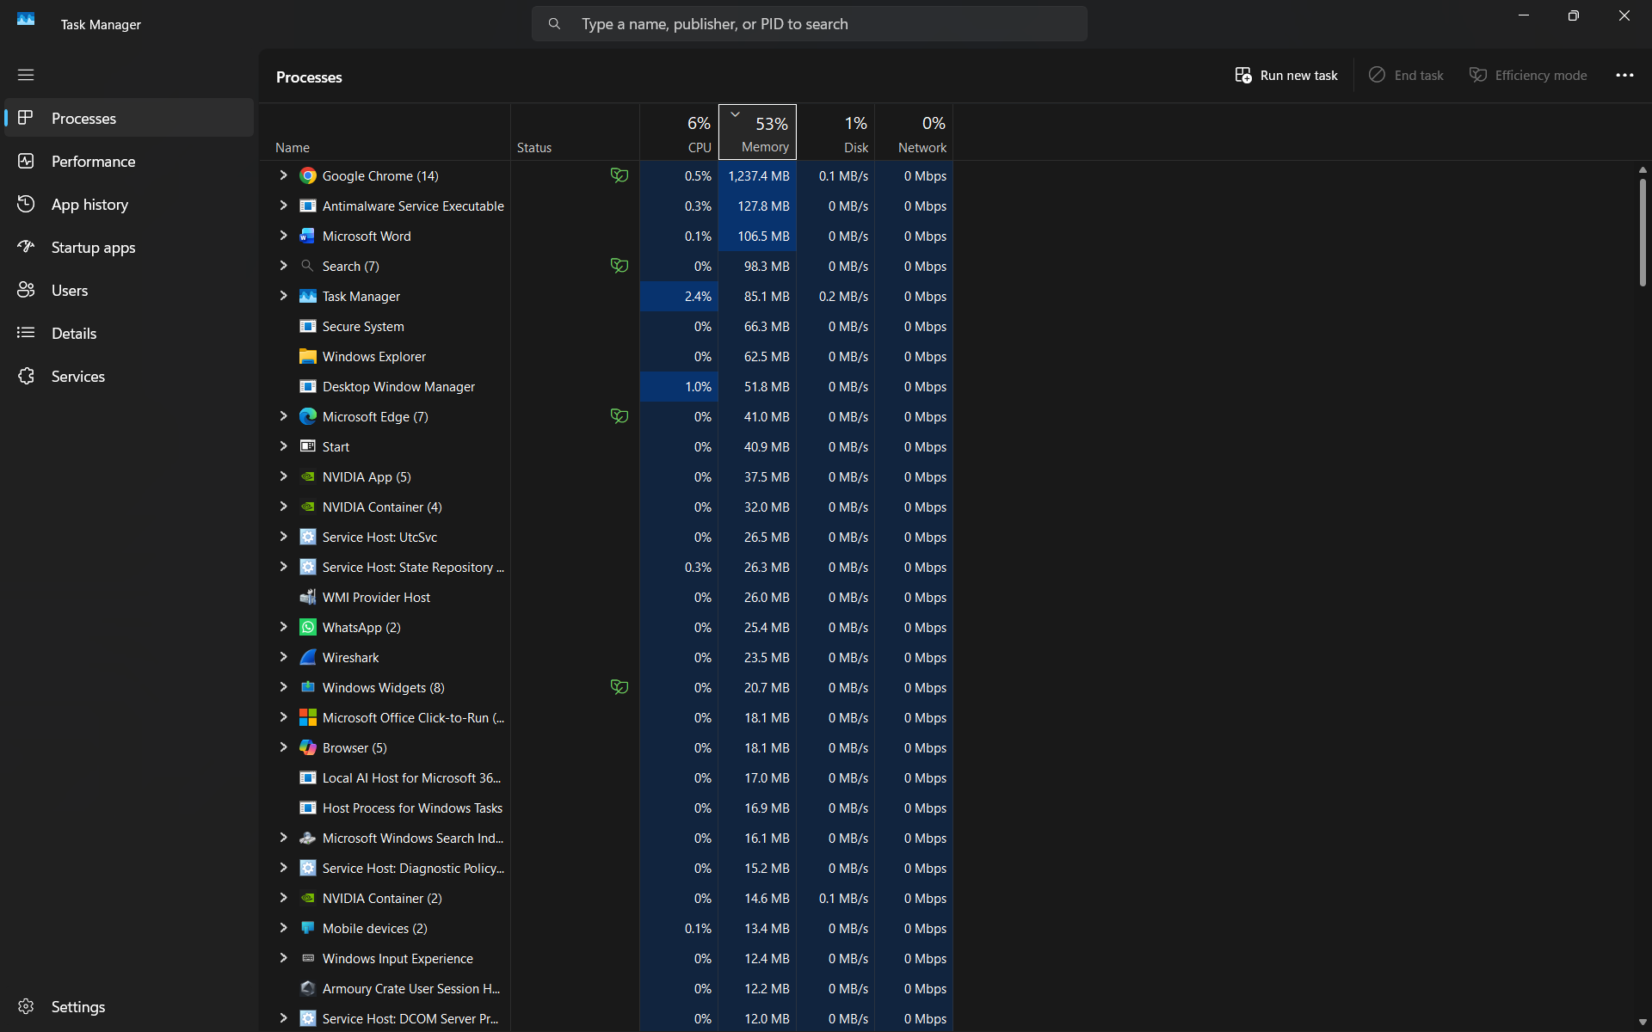

Q4. Download and run the free version of 'Angry IP Scanner' or 'Advanced IP Scanner' to scan your local WiFi network; list the IP and device name of at least 2 devices connected to your network.<br><br><em><strong>Hint:</strong> Make sure your firewall allows scanning, and only scan your own home/college network.</em>?

Answer
To scan the local Wi-Fi network and identify at least two connected devices with their IP addresses and device names.
- Steps:
- Download and install Advanced IP Scanner.
- Connect your laptop to your own Wi-Fi or hotspot.
- Open Advanced IP Scanner.
- Check the IP range shown at the top. It usually detects the local network automatically.
- Click the Scan button.
- Wait until the scan finishes.
- Look at the list of connected devices.
- Note at least 2 devices with their:
  - Device Name
  - IP Address
- Example Observation Table:
Device Name | IP Address
- Redmi-Note-12 | 192.168.102.3
- Galaxy-A14 | 192.168.102.4

- Result:
I successfully scanned the local Wi-Fi network using Advanced IP Scanner and identified connected devices along with their IP addresses.
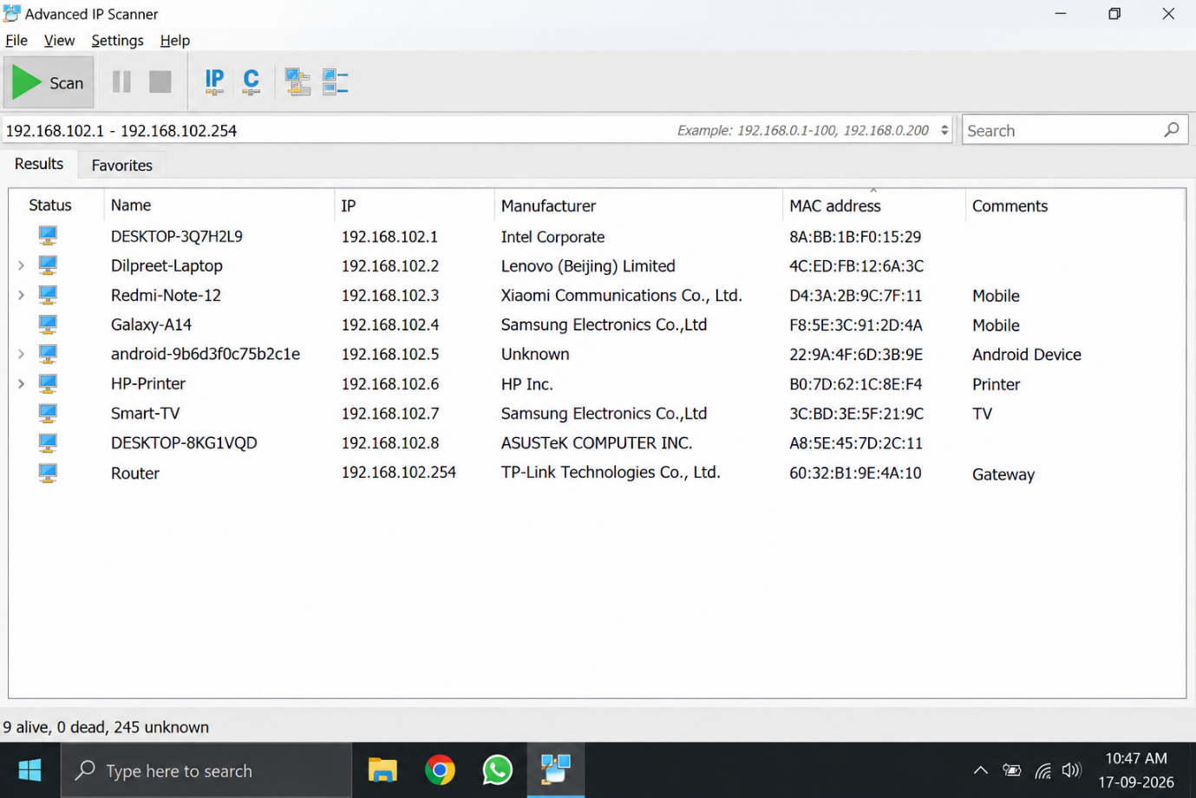

Q5. Use ChatGPT or Bing AI to suggest 3 hardware tools (like cable tester, crimping tool, or multimeter) used in network troubleshooting; for each, write one line describing when you would use it?

Answer
The following hardware tools are commonly used by network technicians to find and fix network problems:

Hardware Tool | Use
1. Cable Tester | Used to check whether a network cable is properly connected and working correctly.
2. Crimping Tool | Used to attach RJ-45 connectors to Ethernet cables.
3. Multimeter | Used to measure voltage, current, and continuity while checking network or electrical equipment.

- Conclusion:
These tools help a network administrator quickly identify cable, connector, and power-related problems in a network.

